The following picture shows a simple maze.

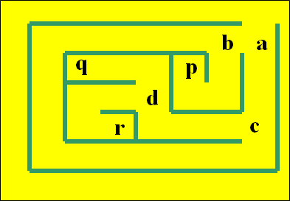

Create a Program that calculates the path between two points. Assume you have the following Prolog facts.

link(a, b).

link(b, p).

link(b, c).

link(c, d).

link(d, q).

link(d, r).

You should be able to answer queries like:

:- path(a,c).

:- path(c,a).

:- path(a,r).

:- path(a, X).